After reading ntuple_array.root and selecting tree;2 used T->MakeClass(“q4_var_check”) to generate the required analysis skeleton and header files.

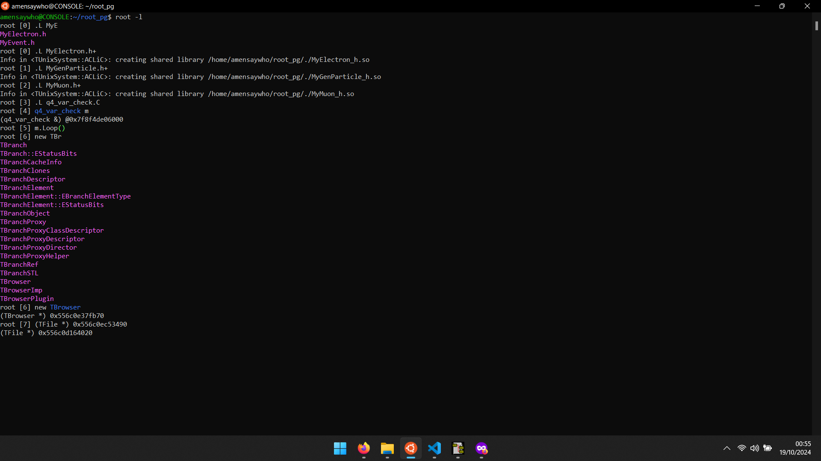

After modifying the analysis loop to separate electron, muon and Generated Particle values into separate vectors, output is written to q4_tree.root

Data structure is verified using TBrowser and cross-checking number of entries against nElectrons in ntuple_array.root

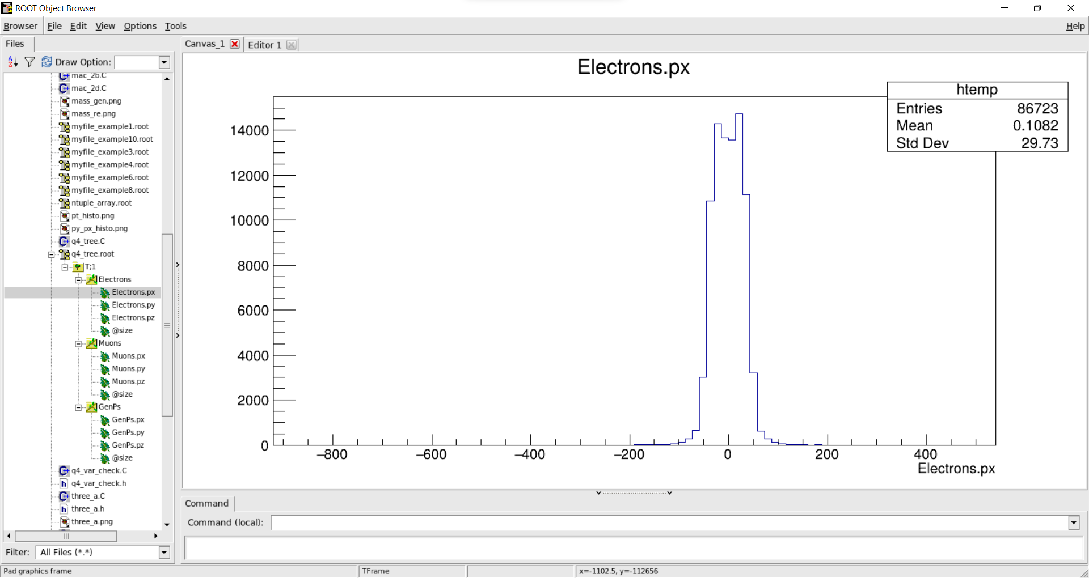

After loading q4_tree.root, we use MakeClass(“Z_mass”) to create the required analysis skeleton and header files. After modifying the analysis loop using LorentzVectors, and adding the obtained values to Histogram, the output is written to q4_z_mass.root

